**Identify the following**

1. **Identify the type of relationship (1:1, 1:m, m:m)**

**1:1**

**Employee:Mechanic**

**Employee:Salesman**

**1:m**

**Car:RepairJob**

**Salesman:Cars**

**Client:Cars**

**M:m**

**Mechanic:RepairJob**

**Salesman:Client**

1. **Identify the cardinality (Min, Max)**
2. 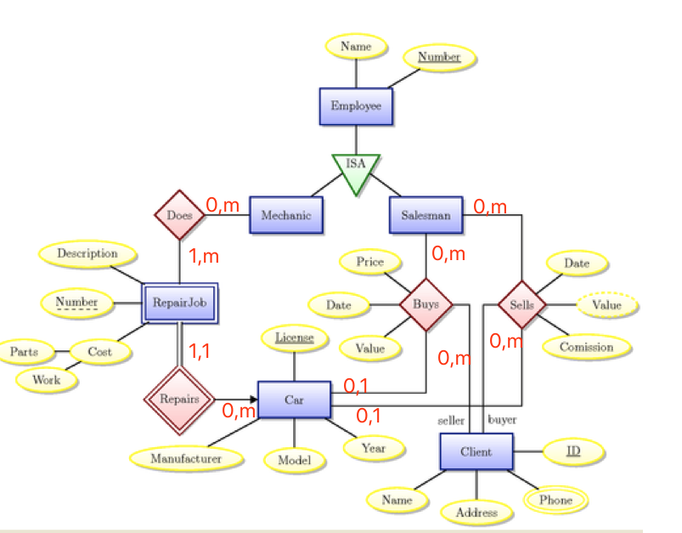

**Primary Key**

Table Employee: Number

Table Repair: Number

Table Cars: License

Table Client: ID

Table Buys: SalesmanNumber, License, ID

Table Sells: SalesmanNumber, License, ID

Table Employee: Number

Table Mechanic: MechanicNumber

Table Salesman: SalesmanNumber

实验过程及内容：(**Methods and steps)**

1. Identify all entities you can think of

* Department
* Employee
* Skills
* Team
* Customers
* Product
* Projects
* Spouse
* Dependent(children of employee)

1. Identify all the attributes
2. Identify atomic, composite and derived attributes
3. Identify Primary key or Composite Primary Key
4. Identify all relationships between the entities
5. Identify any attributes for relationship
6. Identify the type of relationship (1:1, 1:m, m:m)
7. Identify the cardinality (Min, Max)